CODE

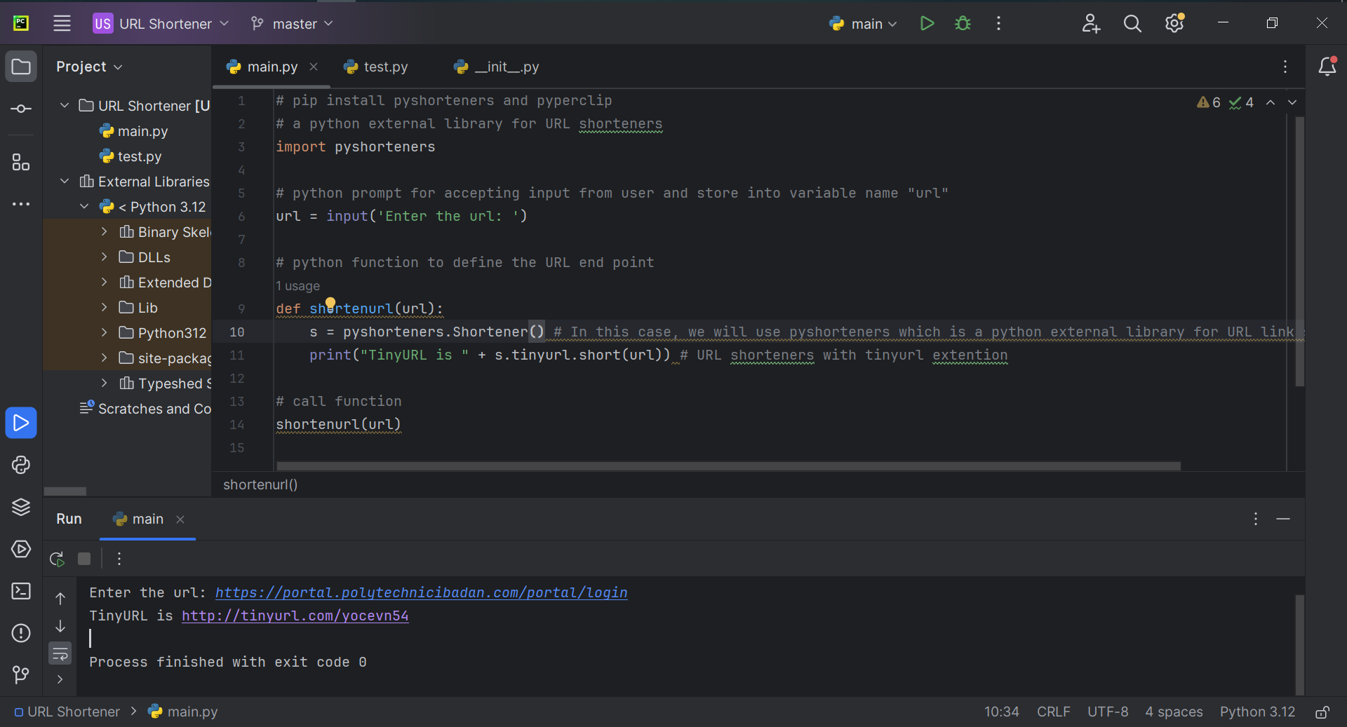

Interted link: https://portal.polytechnicibadan.com/portal/login

Shortened link: http://tinyurl.com/yocevn54

OUTPUT

